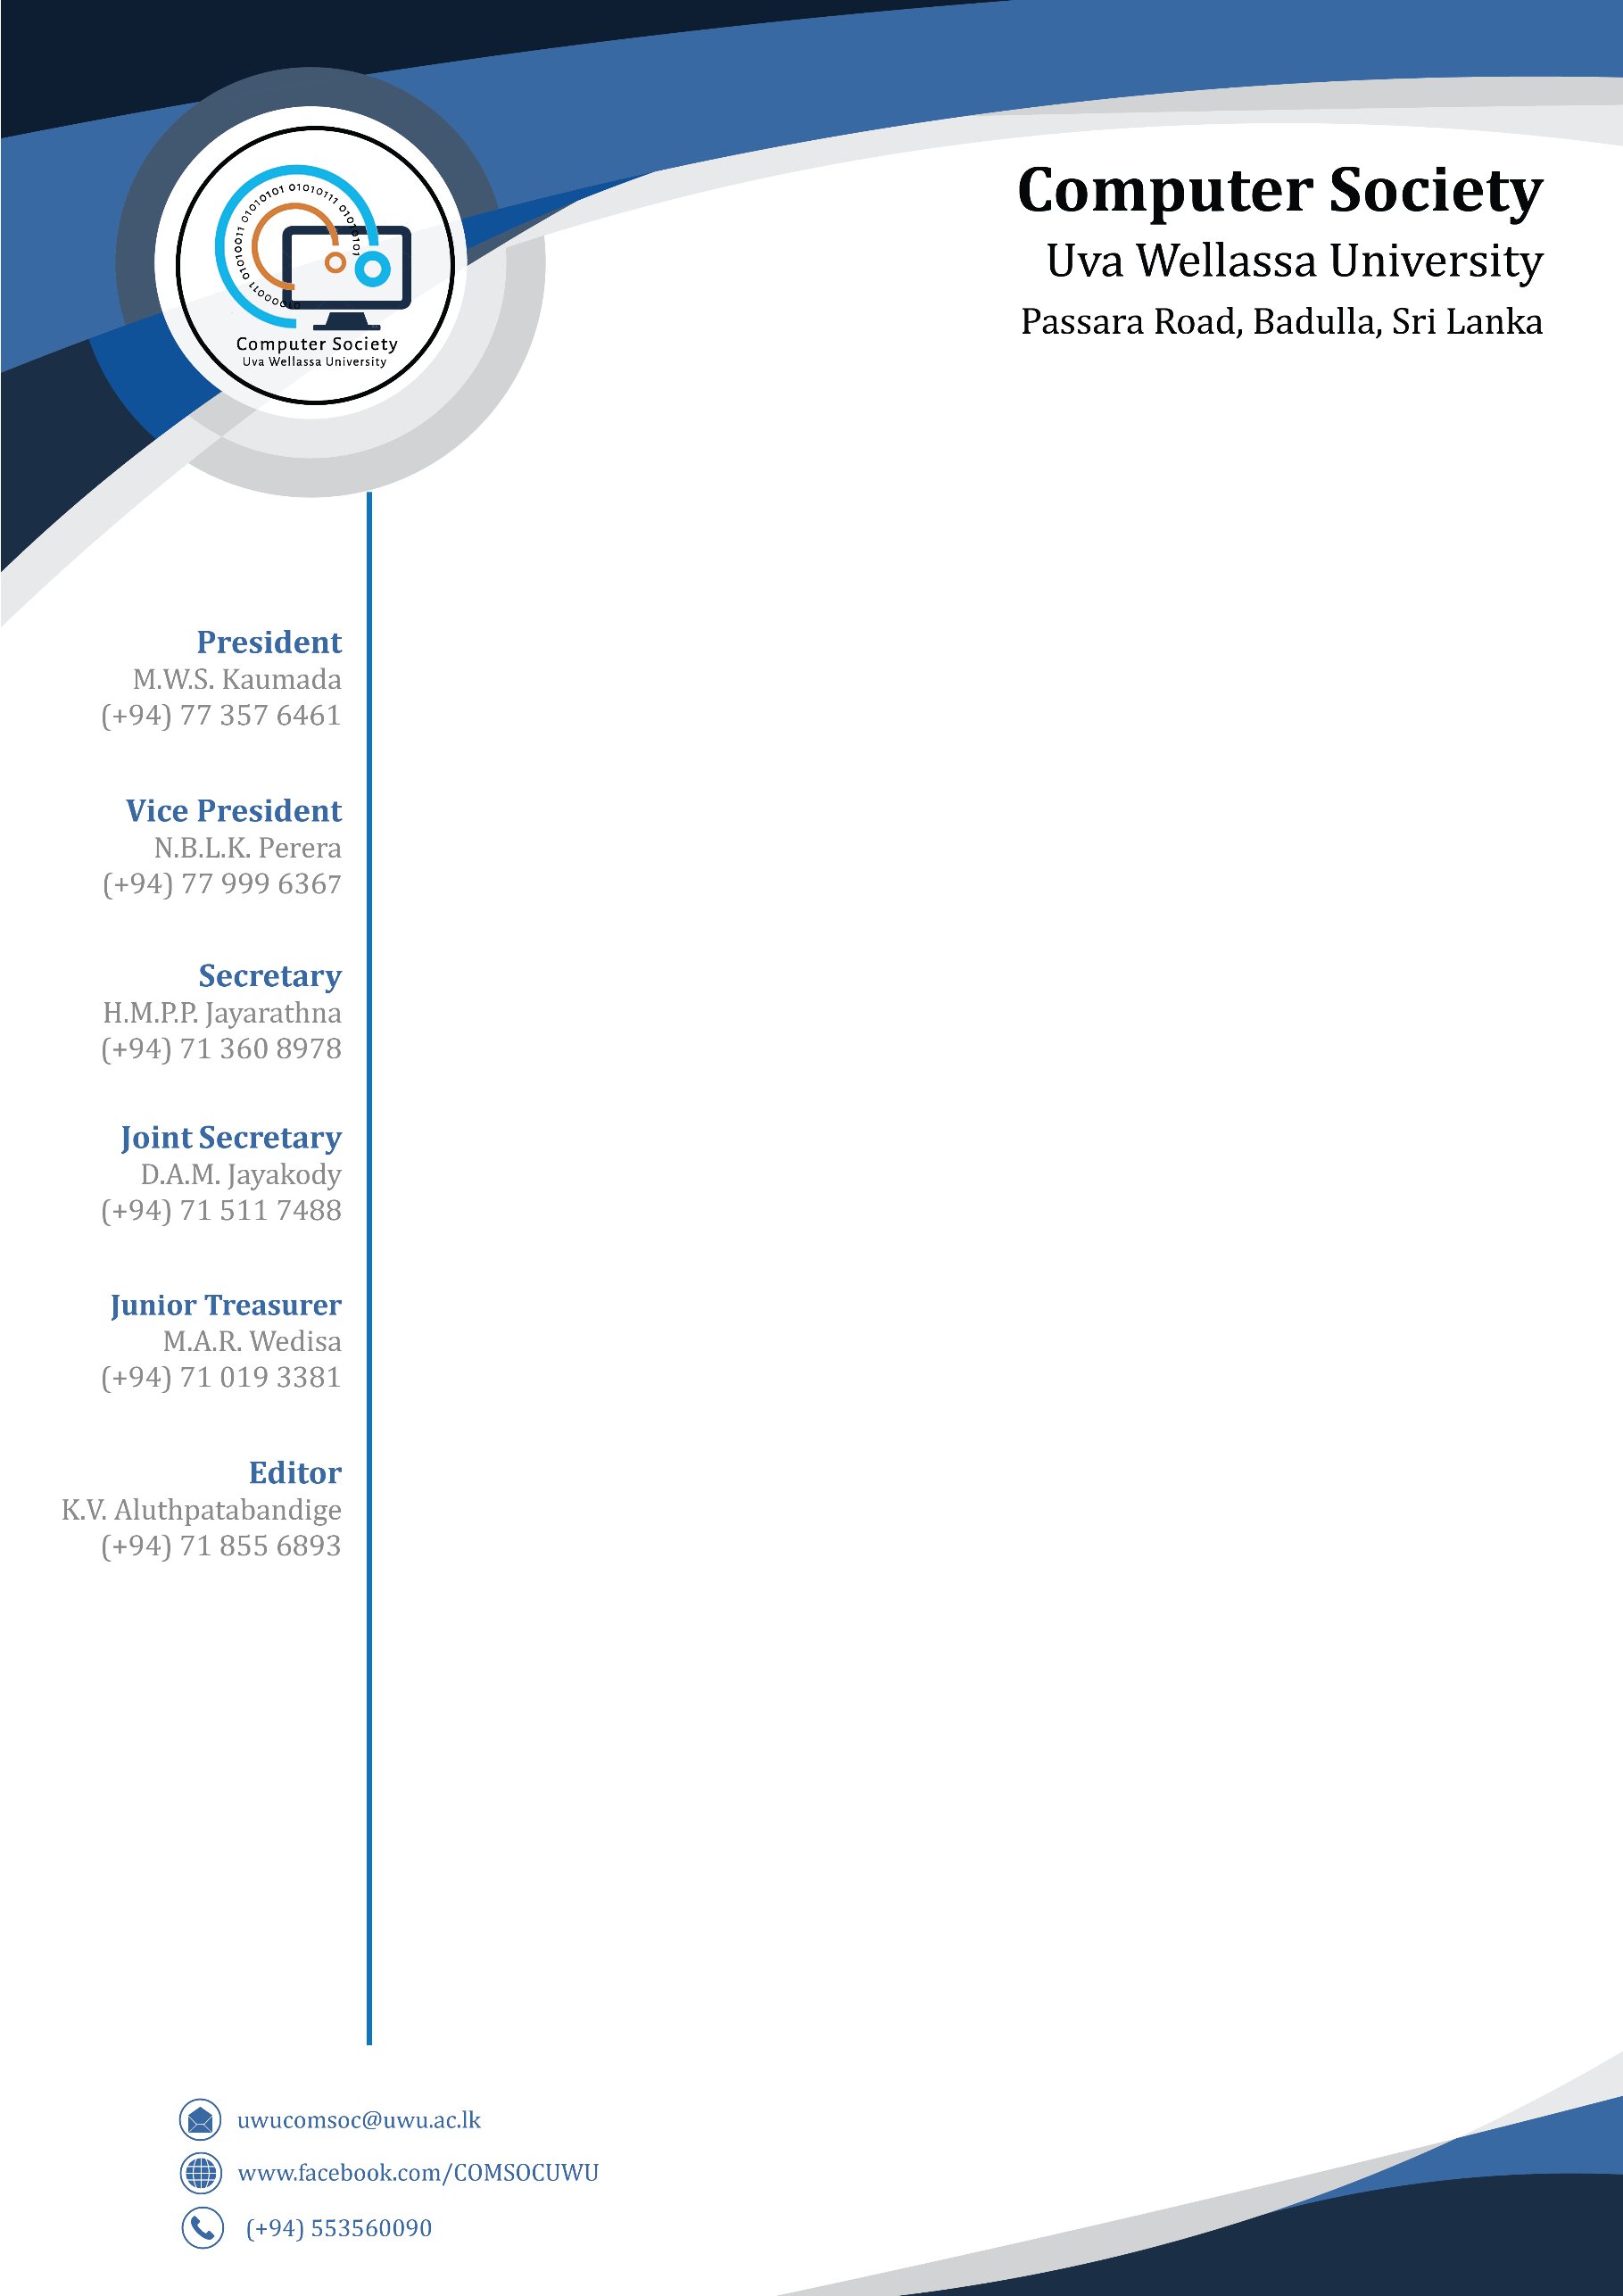

**TO WHOM IT MAY CONCERN**

This is to certify that N.A.D.I.C.S.Gunasekara, a 4th year student of Uva Wellassa University, student registration number UWU/IIT/15/018 has being an active member of the Computer Society of Uva Wellassa University.

The above mentioned undergraduate also has actively participated in Deftcoders V5.0 hackathon in 2018.

This letter is issued at the request of Mr./Ms. N.A.D.I.C.S.Gunasekara.

---------------------------

President,

Computer Society of Uva Wellassa University.